**Project Initialization and Planning Phase**

|  |  |
| --- | --- |
| Date | 15 June 2024 |
| Team ID | SWTID1749712812 |
| Project Name | Unlocking Silent Signals: Decoding Body Language with Mediapipe |
| Maximum Marks | 3 Marks |

**Define Problem Statements (Customer Problem Statement Template):**

The current human-computer interaction systems lack non-verbal communication understanding, reducing their effectiveness and emotional intelligence. In scenarios like remote communication, healthcare, or driver safety, the absence of body language analysis leads to poor engagement or missed cues. To create more intuitive and responsive systems, it is critical to decode body language in real time. This project proposes using MediaPipe and machine learning to extract and interpret facial expressions, hand gestures, and body postures, enabling applications that react intelligently to human non-verbal signals.

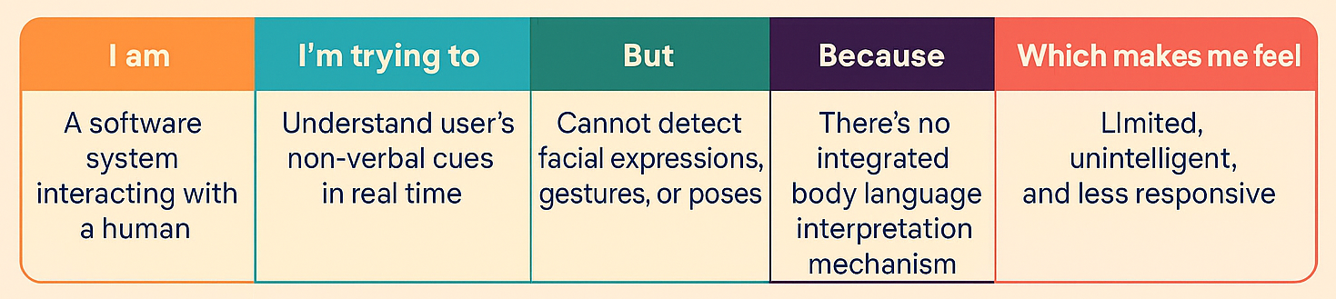

|  |  |  |  |  |  |
| --- | --- | --- | --- | --- | --- |
| **Problem**  **Statement**  **(PS)** | **I am**  **(Customer)** | **I’m trying to** | **But** | **Because** | **Which makes me feel** |
| PS-1 | A software system interacting with a human | Understand user’s non-verbal cues in real time | Cannot detect facial expressions, gestures, or poses | There’s no integrated body language interpretation mechanism | Limited, unintelligent, and less responsive |